Global PaedSurg - Research Training Fellowship
Session 1 - October, 26th 2018

Introduction to the Fellowship,
Developing a Research Question
and Undertaking a Literature Review

- Fellowship Structure
  - 10 monthly one-hour webinars on BlueJeans every last Friday of the month
    - One session for junior researchers
    - One session for senior researchers
  - All sessions are recorded and summaries will be circulated in multiple languages
  - Mentorship provided for collaborators undertaking own project
    - Matching of mentor to mentee over next month (by end of November)
    - Mentor can be local – they do not need to be a member of Global PaedSurg (please email details to globalpaedsurg4@gmail.com if you already have a mentor or suggestion/ request for a mentor)
    - Mentors are expected to have monthly meetings with mentee to support mentee to develop a research project
    - The mentorship is aimed to be two years to allow for completion of a project
    - Research projects can involve any subject – they do not need to be focussed on Paediatric Surgery
    - You can use an existing project for the fellowship
  - Certification will be provided at the end of the fellowship by the Global PaedSurg Research Collaboration, which is being hosted by King’s College London
    - The certificate depicts how many sessions in total attended
    - Note: the Research Training Fellowship is not a formal university course, so there are no credits from King’s College London
    - Reward of presenting and publishing own research (not just ticking the box!)
  - Global PaedSurg Prize Session
    - Established individual research project abstracts can be submitted at the end of the 2-year fellowship
    - Online video-conference to wider Global PaedSurg collaboration
    - Top 3 of abstracts will win a prize
  - Evaluation
    - After each session, a brief feedback form (of 2-5 questions) will be sent to everyone, in order to evaluate and optimise sessions
      - Forms are anonymous
    - At the end of the entire course, an evaluation of research capacity building will occur

- Developing a Research Question
  - What is known and not known about your topic of interest already?
    - Area of study ⇒ Literature review ⇒ research question ⇒ research aim ⇒ research objectives ⇒ methods
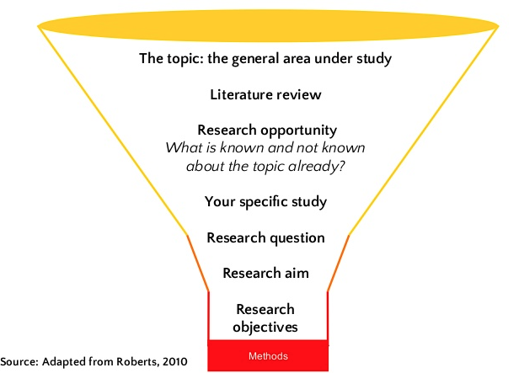
    - Literature review
      - Databases: e.g., PubMed, MEDLINE, Google Scholar
      - HINARI for collaborators in low- and middle-income countries (LMICs) to access articles for free or at low cost
        - http://www.who.int/hinari/en
        - Available in >115 countries
      - (Inter)national surveys/ datasets (e.g., Global Burden of Disease Study)
      - Institute for Health Metrics and Evaluation (IHME) website
        - Country profiles showcasing existing demographic data and burden of disease (e.g., paediatric anomalies, child mortality)
        - http://www.healthdata.org/results/country-profiles
        - Global Burden of Disease Results Tool: http://ghdx.healthdata.org/gbd-results-tool
    - Defining your research question
      - Five core characteristics
        - Is it feasible? (e.g., timeline, costs)
        - Is it interesting?
        - Is it important? (i.e., does it have a clinical impact?)
        - Is it clear and concise?
        - Is it measurable?
      - Examples
        - What are the effects of childhood obesity in the United States?
          - Not good: not specific enough (i.e., which effects? Which population?)
          - Better: how does childhood obesity correlate with academic performance in elementary school children?
        - Should women take hormones to prevent bone loss?
          - Not good: not specific enough (i.e., which hormones? Which population of women?)
          - Better: is taking oestrogen associated with a lower risk of osteoporosis in women over 60?
        - Can a vegetarian diet reverse cardiovascular disease?
          - Not good: not specific enough (i.e., all cardiovascular disease? What is a vegetarian diet specifically comprised of? What do we measure?)
          - Better: does a plant-based diet reduce serum cholesterol levels in patients with cardiovascular disease? (i.e the use of serum cholesterol as a proxy for atherosclerosis and hence cardiovascular disease)
        - Can diabetic patients be taught to control their blood glucose levels?
          - Not good: too broad (all diabetic patients? Which type of diabetes? What type of teaching?)
          - Better: can a structured intensive diabetes education program help patients with type 2 diabetes control their blood glucose levels?
        - What are the outcomes of patients with congenital anomalies globally?
          - Better: what is the mortality and post-operative complication rate for patients born with seven common congenital anomalies in low- and middle-income countries (LMICs) compared to high-income countries (HICs) globally?
  - Additional resources
    - https://airs.library.qut.edu.au/resources/1/1/
    - http://www.socscidiss.bham.ac.uk/research-question.html

- Action Plan
  - Session 2: Choosing your study design
    - Friday November, 30th 2018
    - TO DO
      - Undertake a literature review of your topic
      - Write a 500 word summary
      - Draft your research question
      - Send a copy to your mentor and a copy to globalpaedsurg4@gmail.com

Of note – this is simply a draft to get you thinking about the research topic and to share ideas with your mentor. It does not need to be a finished piece of work.

