Global PaedSurg Research Training Fellowship
Session 5: 29 March, 2019
Data Collection
By Tessa Concepcion
And Professor Adesoji Ademuyiwa

Aim
- To summarise types of data collection and review methods for collecting data

Objectives
- Understand basics of the two main types of data collection: Quantitative and Qualitative
- Review types of quantitative data and benefits of each type
- Summarize methods of collecting data

Types of Data Collection
Can be grouped into Quantitative and Qualitative

Quantitative

Surveys
Cross-sectional
Longitudinal
Hospital patient data
Prospective
Retrospective
Qualitative

Interviews
Focus Groups

Quantitative Data

Surveys
Can be Cross-sectional or Longitudinal

Cross sectional

Takes place once across a population
Example: SOSAS Study
Pros: Quick, immediate results
Cons: Limited in analysis as population may not

Longitudinal

Repeated observation on same population and same variables
Can be done over a short or long period of time
Example: US census, Demographic Health Survey
Pro: Assess and show change over time, can show causality
Cons: Time consuming and costly

Other aspects to consider

- Population survey – Entire population (may give accurate data but is costly) vs part of population (certain group in population )
- Content of survey – what are you asking about, if its sensitive information, stigmatised
- Length of survey – can be one page (few aspects) or long (very long) takes more time

Examples of surveys
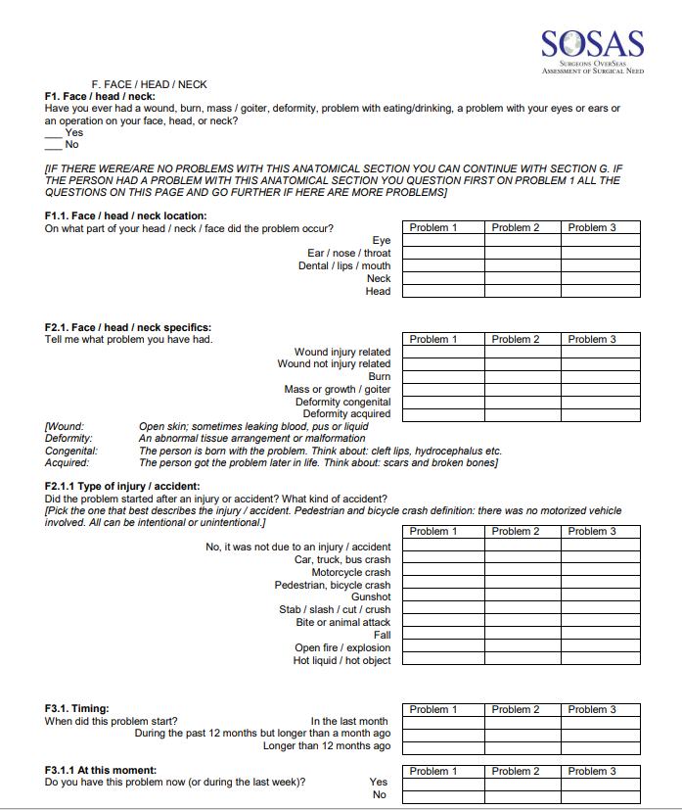
Complicated
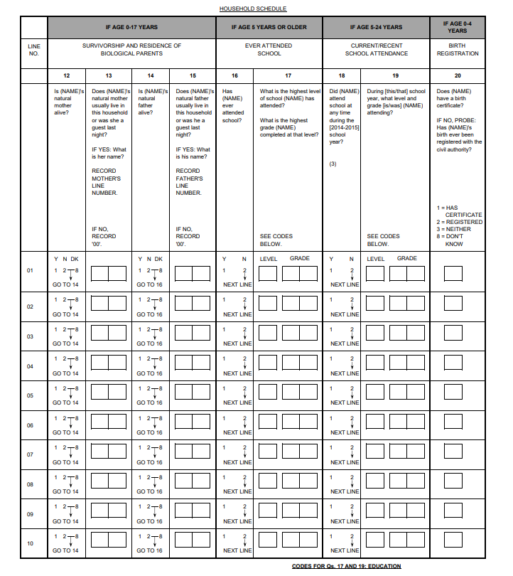
Simple
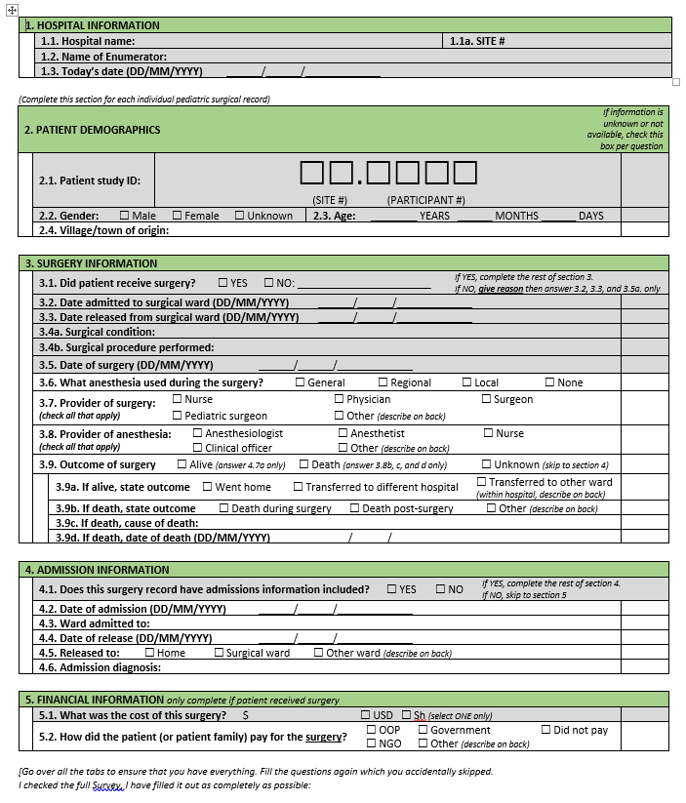
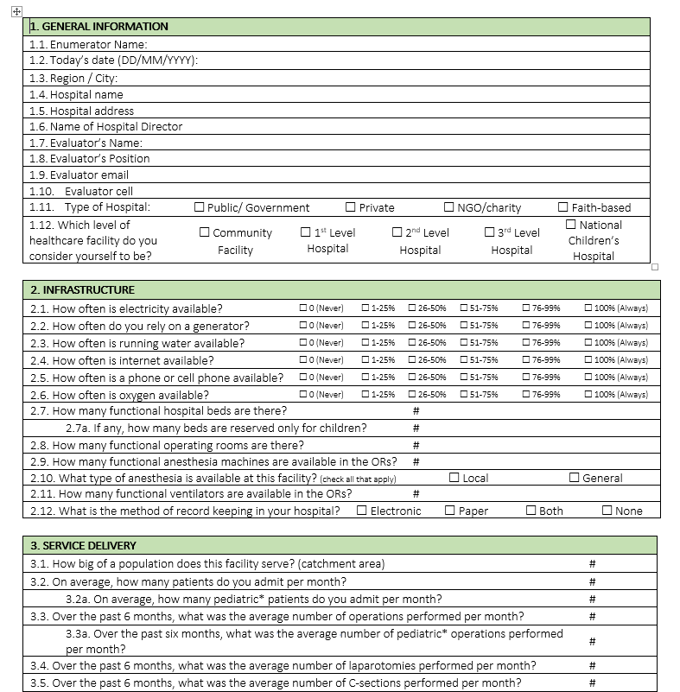

Hospital patient data

Common way to collect data for any disease or illness
Prospective vs retrospective

Prospective – Future Sampling

- Design survey or data collection method
- Data is collected from now into the future for those who present with certain diseases
- Allows one to gather specific variables such as cause of presentation
- Better understanding of the context
- Time consuming

Retrospective – past Sampling

- Makes use of previous patient records
- Tends to be quicker and cheaper
- Limited in control of variables
- Limited understanding of context

Types of quantitative data

Types of questions asked can be:

- Binomial – yes or no / true or falls, one would need to ask more questions
- Nominal – colour (no order)
- Ordinal – Scale of 1 -10

Types of answers collected can be:

- Closed answer
  - Provide options for answering
  - Give room for analysis

- Open answer
  - Participant writes in answer
  - Great for gathering supplemental information about condition
  - Can be informative but difficult to analyse later

Qualitative Data
- Done at the beginning and end of a project.
- Can be conducted via interviews or focus groups

Interviews
- Most common type
- Personal approach typically one-on-one
- Interview leads to discussion

Structured
- A list of open-ended questions

Semi-structured
- Some questions are predetermined but interview is flexible to change depending on the response of the patient

Unstructured
- Topic for interview is determined, but interview is more of a conversation with no particular agenda

Key Informant Interviews
- In-depth interviews with people who know what’s going on in the community e.g. community leader, religious leader, WHO official

Focus Groups

- Group discussion session
- Allows one to get more information from more people at one time
- Ideas can be deliberated
- Limited to 6-10 people, all having something in common
- Moderator to guide the conversations
- Long discussions

Methods of Data Collection

Paper and pencil
- Pros: Mobile, easy to use, no need for internet
- Cons: Expensive, data security issues

Electronic

REDCap https://www.project-redcap.org/
- Pros: Free to non-profit organizations, complex survey capable, online and offline options (once connected to the internet, the data will upload itself onto the cloud storage service), mobile options
- Cons: Must be affiliated with organization

Microsoft Access
- Pros: Within Microsoft programs, secure
- Cons: Can be difficult to learn/manage

Microsoft Excel/Google Sheets
- Pros: Easy to use
- Cons: Not as secure, introduces room for error

Open Data Kit (ODK) https://opendatakit.org/
- Pros: Free, easy to use, similar to REDCap

Other Data Collection Methods

- Audio recording/transcribing
- Phone interview
- In person interview

Data Collectors - Things to consider

Training time

- Depends on how complicated the survey is
- How to ask questions
- How to record the answer
- Do some exercises to assess understanding

Travel time

- How far are they going to collect the data?
- Is it a village that is far off or it’s a place within reach?

Compensation

- Varies from types of survey, time taken for data collection, country or region you’re in.

Expertise needed

- Work with experienced data collectors such as nurses or public health officers.

Language and culture barriers

- It’s better to work with data collectors from within the community, as they know more about the language and culture in this community

Resources used
https://www.surgeonsoverseas.org/resources/
https://www.nsf.gov/pubs/2002/nsf02057/nsf02057_4.pdf
https://www.project-redcap.org/
http://healthpolicy.ucla.edu/programs/health-data/trainings/documents/tw_cba23.pdf

