Global PaedSurg Research Training Fellowship
Session 8: 29 June 2019
Preparing an abstract for submission at a conference for presentation

By:
Samir K. Gadepalli, MSc, MD, MBA
Assistant Professor, Pediatric Surgery and Surgical Critical Care
University of Michigan
Ann Arbor, MI, USA

Preparing for an abstract

- Know the audience of your presentation - Make presentation carry relevant information for your audience
- Follow the guidelines given by the conference organisers – clarify if the conference will require you to only present your abstract at that specific conference or you’ll be able to present it at other similar conferences. These rules may vary from conference to conference. Prepare a manuscript together with your abstract in the event that it is also requested by the conference organisers.
- Anatomy of an abstract
  - Background/Purpose (Why?)
  - Methods (How?)
  - Results (What?)
  - Conclusions (So what?)
- An abstract is a trailer for the movie, this draws people to the conference. It may be chosen based on its relevance, audience precision (appropriate), strict adherence to guidelines and anatomy of study is as expected as well as a good catch.

Anatomy of abstract.

Background

Background/purpose/introduction – defines the why, why do we want to do this study
- 1-3 lines long
- First sentence – what we know, main character, right altitude – the first sentence depicts the level to which the audience will need to be focused on.
- Second sentence – sometimes included in the first or third for space – focuses on the problem that needs to be solved, looking at the unknown gap existing within the literature or the field
- Third sentence – how will the problem be solved, hypothesis establishment is at this sentence

For example
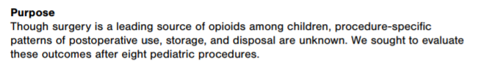
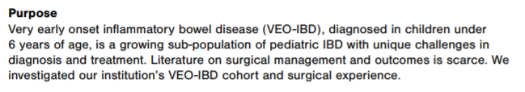

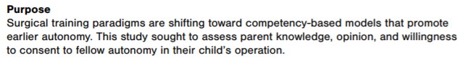

Methods

Objective review of what is to be done/ was done in the study

- Length varies
- Detail matters
- Key components
  - IRB – internal review board, ethics approval from the board
  - Population/Data source – large data registries, source of registry and how it was obtained
  - Definitions – how to define specific populations, and words used in the study, exclusion and inclusion criteria
  - Approach – type of study design used, retrospective, RCT, prospective, survey
  - Stats used
  - Demographics, intervention, outcomes, stats
- Do not confuse results and methods

Example
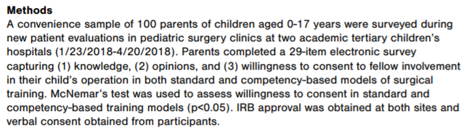

Results
Details the findings of the study
Results and methods are very complementary as they determine if an abstract is chosen for presentation at the conference
- Start HERE – does the whole story make sense
- Do I want to hear more about this project?
- Be organized
- Use your tables/figures wisely
- Most important findings - Focus on your main findings,
- Interpret but don’t judge – objective evidence based interpretation
- Complementary with methods – must be concurrent
- Are decimal points necessary? How many? Are they necessary in the abstract?
- A good results section will get your abstract accepted
- Not because of the findings but on how it’s presented – presented in a logical fashion that’s understandable.
- Typically I do it in 3-4 levels
  - Population studied: Demographics – mean versus median
  - Comparison of groups: p-values, confidence intervals important
  - Outcomes: make sure to appropriately adjust for regression (present what was used for adjustment in methods e.g. confounders)
  - Most important finding: Table/Figure. Is the information understandable?
  - Is it tweetable? The table should entice individuals to read the study.
- The reader should get to the conclusion before reading it!!
Example
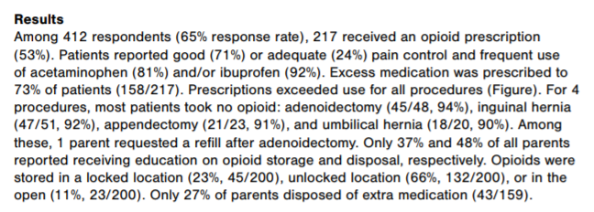

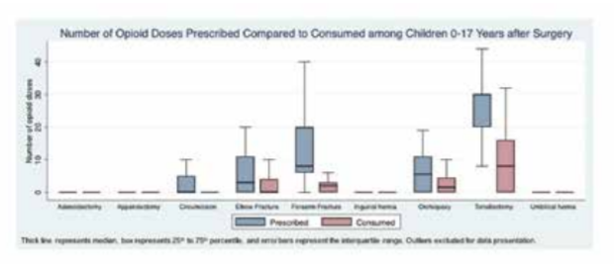

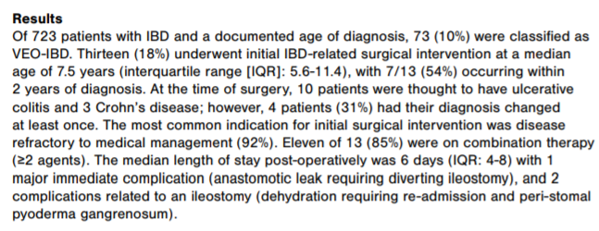
Example 2
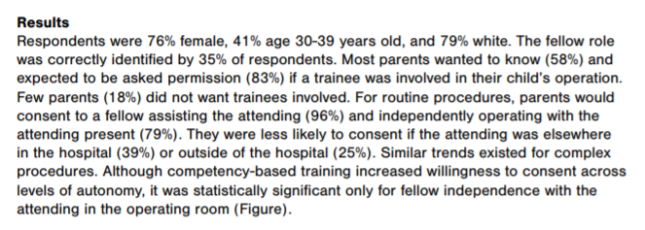
Example 3

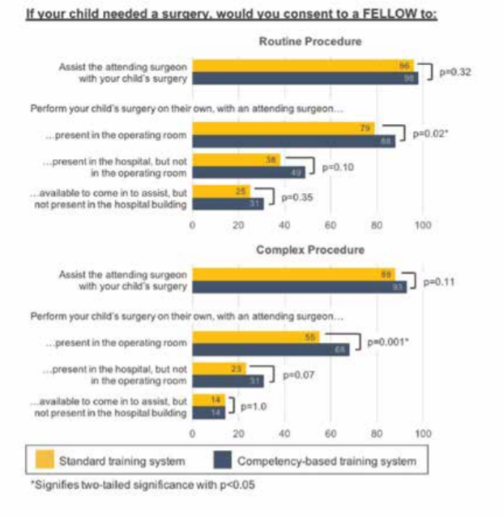

Conclusion
- Last thing I write but first thing I think about
- Talk about what was done and what was found.
- Just by looking at figures/tables, you should be able to tell the takeaways
- What are the implications/main findings?
- Why should this be the abstract chosen – “first one”, “largest”, “unexpected findings”, “important problem”
- Keep it simple. Make it easy to read.
- And Memorable!
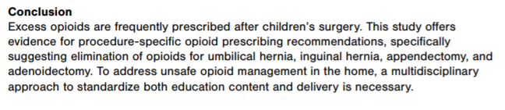
Example
