Global PaedSurg Research Training Fellowship
Session 10: 27 September 2019
Journal Selection and Submitting for Publication
By:
Nathan Novotny, MD, FACS, FAAP

Objectives
- Understand the reason for publishing scientific works
- Accurately assess your manuscript and which journal is the best fit
- Identify characteristics of journals with scientific value
- Identify characteristics of journals that simply want your $$
- Understand where to find and how to properly format your publication prior to submission

Background:
- Everyone wants to provide the best care to his/her patients
- By making an impact
- By publishing

BMJ says
- Make sure your paper fits within the scope of the journal
- Assess the credentials of the journal or publisher
- Browse the content they publish for quality and relevance to your field
- Check the quality of their website
- Check what tools and services they offer to authors
- Submit your research to one journal only, but check if they offer transfers to other journals
- Follow the instructions for authors carefully
Source: https://authors.bmj.com/before-you-submit/how-to-choose-a-journal/

Make sure your paper fits within the scope of the journal
- Somewhat self-explanatory
- And yet don’t think only ped surgical journals
- Other options include:
- Adult GNS
- Peds
- Peds subspecialties (EM, GI, Crit Care, ID, etc)
- Global Health
- Public Health

Assess the credentials of the journal or publisher
- What are objective measures of a journal’s importance/difficulty in acceptance?
- Impact factor
- Quartile (SCImago link)
- Your own history

Impact factor
- Probably the most well known
- Calculated over a two year period
- Simple calculation of number of times cited divided by citable articles
- Manipulated
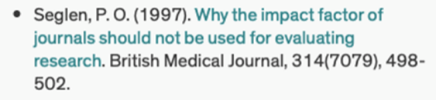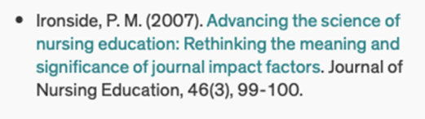
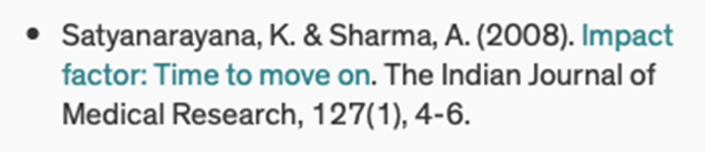
Quartile
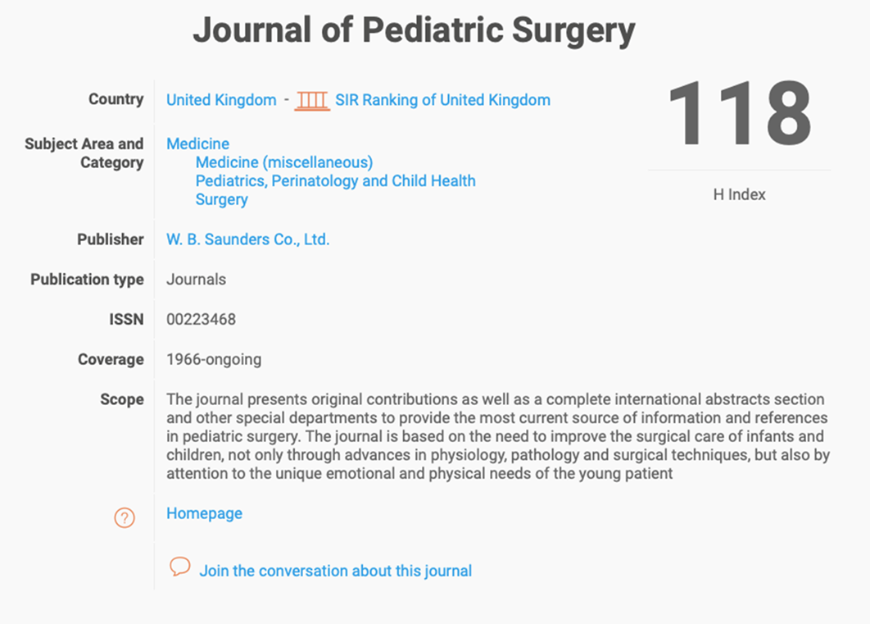

Why look at all this?
Identification of the appropriate journal for your manuscript.
Your own history

Browse the Content of the Journal and Compare to your Manuscript:
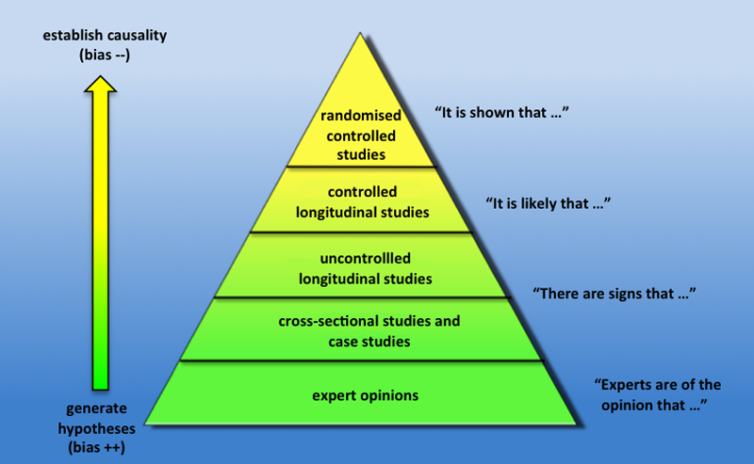
- Level of evidence
- Your expertise in the field
- Your institution’s reputation
- Results
- Timeliness (eg. vaping)
- Size of population
- Effort, overall quality, novelty

Check the journal’s website
- Do they have one???
- Can you easily contact the journal?
- Is the publisher clearly displayed?
- Would you read the articles published?
- Are they clear about fees, if any?
- Who is on the editorial board?*
- Think Check Submit
- Directory of Open Access Journals

Check what services are offered to the authors
- Web-based submission vs. ‘send us your abstract via email’
- Assistance in choosing the right journal (Elsevier)- Interesting but proprietary...
- Review and publication speed is often published now

- Submit your Manuscript to One Journal at a Time
Author Instructions
- Every journal has them
- Some are more demanding than others
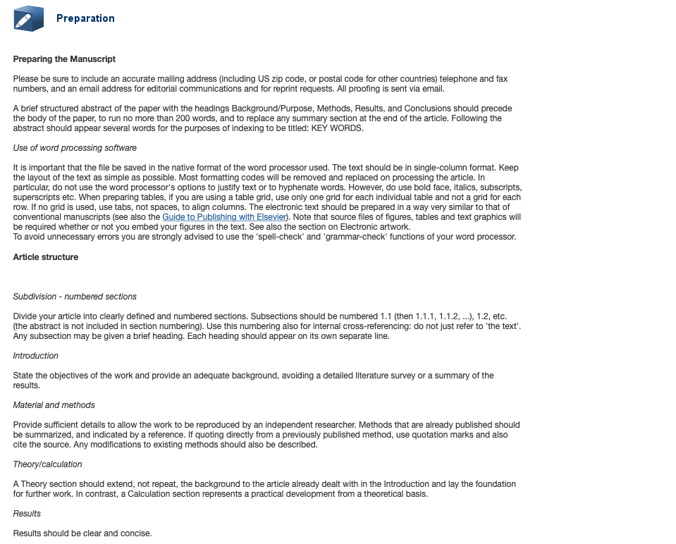
Wordy Neh?

But you avoid this
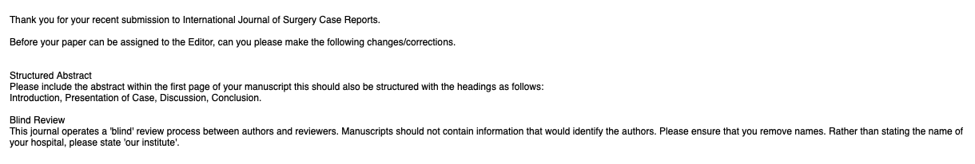

Conference associated journals
- Major national and international conferences (APSA, BAPS, PAPS, EUPSA, IPEG, WOFAPS, International Colorectal Club, and more)
- Typically, a higher percent-acceptance rate
- Quick response
- More ‘hits’ on your CV
- Downside: cost of travel, conference, etc.

