Global PaedSurg Research Training Fellowship
Session 9: 26 July 2019
Writing a manuscript for publication

By:
Professor Lars Hagander (Lund University, Sweden)

Learning objectives

How to prepare a scientific manuscript:
- Structure of a scientific manuscript
- Order of preparation
- Stakeholders
- Writing style
NB: We may not always be successful with our scientific manuscripts as not a lot of people may have impaired concentration. Be concise, have a clear message focusing on the reader as you write.
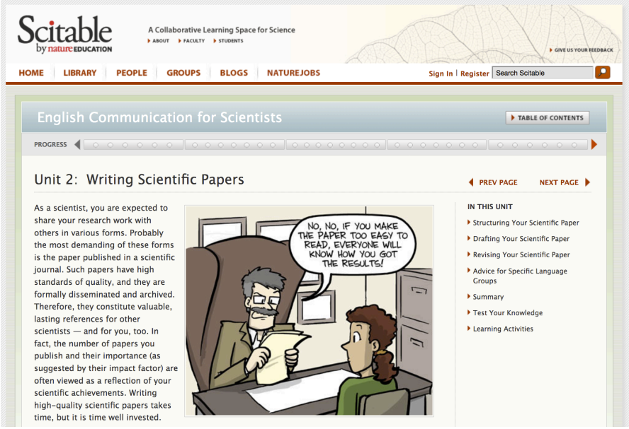
Site: https://www.nature.com/scitable/ebooks/english-communication-for-scientists-14053993/writing-scientific-papers-14239285/

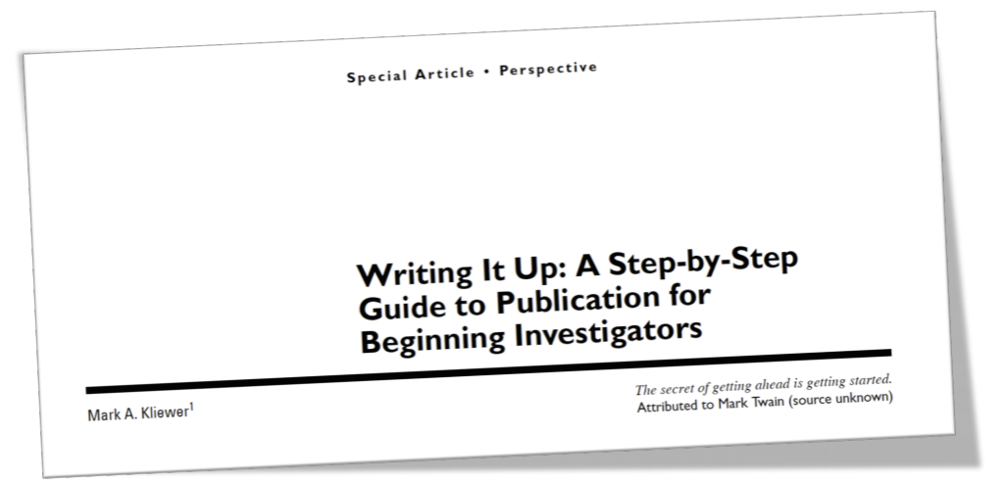
Kliewer MA. AJR 2005; 185:591.–596 2006

Structure of a scientific manuscript

Outline
- Title
- (Title page: Keywords)
- Abstract
- I-M-R-D [imrad]
- Conclusion
- (Acknowledgement)
- (References)
- Tables and Figures
- Supplementary material

How readers will read your work
Order may differ but it may follow this route:

First
- Title
- Abstract: first and last sentence
- The rest of the abstract
- Tables and figures
- If you have referenced them – Reference List

Second
- Any methodological issues?
- Are they properly done?

Then
- Introduction – results - discussion

How writers write

First
- Methods – really get a clear grasp on how you define your variables, results and exposure, shared vision among author team on what is to happen.
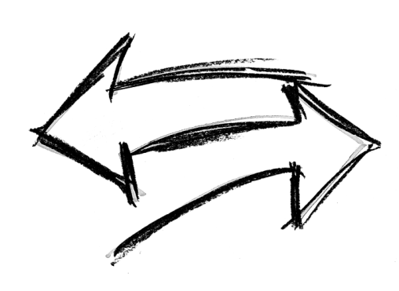
- Tables and figures

Second
- Introduction
- Results

Third
- Discussion
- Abstract
- Title
- Conclusion

Title
- Attracts attention
- Meaningful at a PubMed screen
- Specific
- Reflect the content of the manuscript
- Sell or tell?
- Summarize the findings?
- Study design as a subtitle? [Via Title: Subtitle]

Abstract
- Lure the reader to read on
- Prepare the reader for what is to come
- Wider audience than the rest of the manuscript
- Quite variable journal preferences (how many headings, how many words allowed)

- Introduction: State the context, need, task, objective
- Methods: Study design, outcome and exposure.
- Results: The what (Numbers, numbers, numbers)
- Conclusion: The so what. Reflect the objective. Perspectives?

- Introduction and conclusion – most important that should really attract attention of the reader.

Introduction
- A rationale, the motivation indicating the importance of this paper.
- Prepare readers for the structure of the paper
- A funnel
- 3 paragraphs long

1st paragraph
- Big picture. Issue. Context.
- Orient the reader and establish importance
- Provide a compelling motivation
- Words from title in first sentence? Don’t be too general in the first sentence
- Anchor in time ( such as since the 1990s, or in paediatric surgery today), space or field?

2nd paragraph
- Narrow down from what is known ––- to what is needed (contradiction or next logical step)
- A gap-statement in the last sentence: “However,…” or “Unfortunately,…” Gap statements sets you up
- Rhetoric research question?
- Less is more. Only what will help readers understand the need, and its importance

3rd paragraph
- The task. What you have done.
- Start with “To address this.., we developed…”. To establish the.., we investigated…”
- The hypothesis
- The purpose and object – what you have done e.g. “This paper describes…” This clearly outline the contribution of the paper
- All this prepares the reader for what is to come.

Methods
- Prepares the reader mentally for the results section
- (Constructive alignment for investigators)
- Conveys a sense of quality
- Sufficient detail for others to reproduce - for other researchers in the future.

Advice
- Start sentences with the key word
- Be 100% consistent with nomenclature and order. Order to be the same as that in the tables.
- Repeat the structure of sentences. Very dry!
- If a paragraph is like a bullet point list in words – let the first sentence introduce and summarize.
- Use subheadings with methodological key-words

Methods –subheading examples
The study design and setting – describe the setting of this study design
- Inclusion and exclusion criteria
  - Perhaps also control group and censoring. Flow chart is very useful. Define the control group, describe how you treat missing variables and censoring.
- Primary outcome
  - “Primary outcome was x… X was defined as…”
- Primary exposure
  - “Primary exposure was y”. Y was defined as…”
- Independent variables and confounders – all other variables which are not exposure or outcome.
  - “Independent variables were [z and k]. Z was defined as… K was categorized…”
- Data collection and validation
- Statistical analysis – how will you present the descriptive statistics; which tests you use; what level is your significance in this analysis.
- Ethical considerations
Results – usually written after table and figures are ready

Style
- One paragraph per table/figure (in order of appearance)
- State the message of each paragraph in the first sentence
- Summarize each table/figure, but do not repeat all numbers
- No methods, no discussion, no references
- Focus on what was found, not that you found it
- Double-check alignment with methods

- Effect estimates with uncertainty
  - Mean with [95% CI] - normal data
  - Median with [a range] - non-normal data

Tables and Figures
- Illustrate major findings
- Answer research questions and address study aim
- Economy and advertisement

“The Table 1” – present your material here
- Columns by exposure
- Are the groups comparable?
- Value of p-value?

The other tables and figures
- Max 4. The rest will be supplementary material
- Figures > Tables
- One per research question or outcome
- Display outcome. Tables have columns by outcome

Captions
- Above tables. Below Figures
- Key words first
- Try to align/answer research questions or study aim
- Comprehensive enough to speak for itself in a ppt

Style
- Be creative, be clear
- Double-check consistency of terms and order
- Copy journal style
- Figures without 3D-effects and colour. No pie-charts
- Tables without grid and without units in cell

Discussion

Style
- Relative freedom (but adhere to journal style)
- I aim for six paragraphs, including conclusion
- Don’t lose your reader. Write clearly and briefly.
- Do not introduce new results
- Use subheadings (and then remove them)
Subheading Examples
1st paragraph
- “To get everyone on the same page”
- Mention the study design
- Claim that you have achieved the purpose e.g. “In this controlled cohort study we have managed to ,…”
- State the principle findings in one, max two sentences
2nd paragraph
- Advance from findings to interpretations – help reader to understand what the results actually mean
- Don’t understate the importance of your findings
- Don’t extrapolate beyond the evidence
- Stay on topic

3rd paragraph
- How your findings are congruent with current thinking and previous literature.
- Yes, one paragraph!! (or two if you have two main findings and don’t want to write two papers…)
- You don’t have to repeat everything from the 2nd paragraph of the introduction.

4th paragraph
- Articulate the clinical implications of your findings
- Explain how your findings illuminate larger issues
- Outline the scientific trajectory
5th paragraph – Limitations
- Let the readers understand the limits of your data and interpretations
- Be honest, thoughtful and self-critical without undermining the validity of your study, as you describe your weakness, remind readers of all the strengths.
- Try to mention strengths en passant as you present your weaknesses

Conclusion
- 6th paragraph
- (In many journals this is a separate heading)
- The shorter the more impressive. Just a few sentences
- Do not restate what you have done or what the paper does
- Focus on what you have found and, especially, on what your findings mean
- Explain what is new without exaggerating
- Align with gap statement, research question, and study aim

Author instructions

Consensus formats
The EQUATOR network – http://www.equatornetwork.org/

Journals
- JPS – https://www.elsevier.com/journals/journal-ofpediatric-surgery/0022-3468/guide-for-authors
- EJPS – https://www.thieme.com/media/ita/pubid1467873712.pdf
- Paediatrics –https://www.aappublications.org/content/pediatrics-authorguidelines
- JAMA paediatrics – https://jamanetwork.com/journals/jamapediatrics/pages/instructions-for-authors

Consider your audience

Your readers
- Value and usefulness
- Citations
- Reputation

Your editors
- Citation potential, to increase impact factor: you have to sell your paper to make it easy to reference
- Space and time – can be limiting factors

Your reviewers
- They read while multi-tasking; envision them with distraction such as social media, children etc.
- Give them what they want, when they want it
- You want them to love you (not to hate you) write simple and clear

General advice on style
- Don’t end long sentences with important verbs
- Care about the bridge between sentences
- Start paragraphs with the message – then present the evidence to support the statement
- Start sentences with the name of the variable
- Readers don’t want to remember long pieces of text before knowing what to do with them
- 100% consistency of terminology and order
- Always past tense? Active or passive?
- Not comma as decimal separator
- Not unlimited space – economy. Be concise
- Check out: https://www.nature.com/scitable/ebooks/englishcommunication-forscientists-14053993/126083980#bookContentViewAreaDivID
- Accept to review papers

Specific language advice
- German and Dutch: https://www.nature.com/scitable/ebooks/english-communication-forscientists-14053993/126084360#headerAndCitation
- French, Italian and Spanish: https://www.nature.com/scitable/ebooks/english-communication-forscientists-14053993/126084360#headerAndCitation
- Chinese and Japanese: https://www.nature.com/scitable/ebooks/english-communication-forscientists-14053993/126084360#headerAndCitation

Recap… Learning Objectives
How to prepare a scientific manuscript:
- Structure of a scientific manuscript
- Order of preparation
- Consider your audience
- Writing style

